Test Case: tc006_SPX_Dev5_Crear_Requisicion_Spot_Tipo_Cobro_Proyect_Urgent
Step 1 - Enter username and password and click to button Enter: Credentials Entered
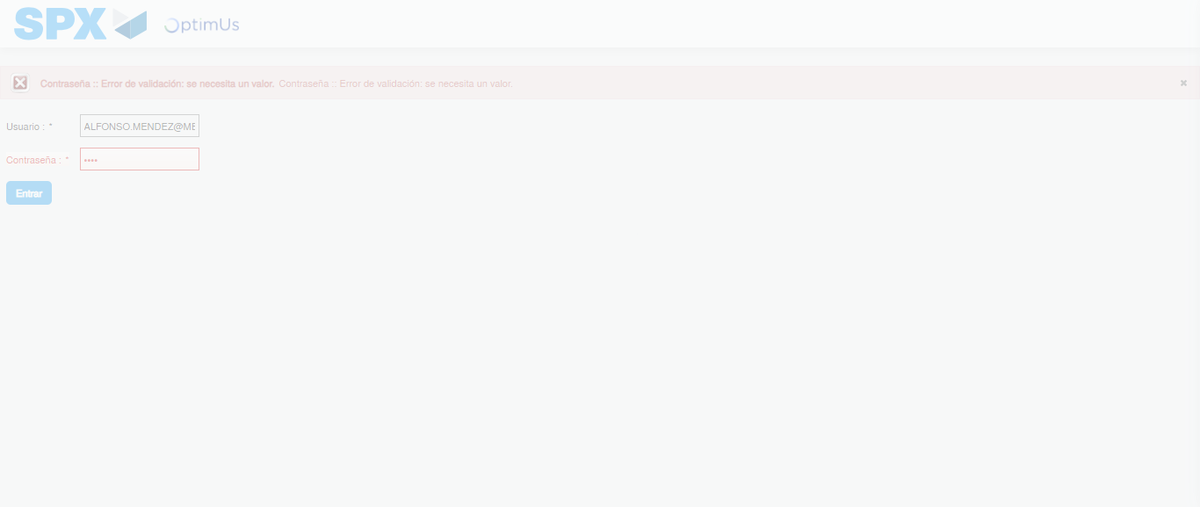Image file-name: QC_Testing-tc006_SPX_Dev5_Crear_Requisicion_Spot_Tipo_Cobro_Proyect_Urgent-1783362584148

Step 2 - Select to UEN and Access to Spot Buy Requisitions : UEN Correctly selected and Correct access
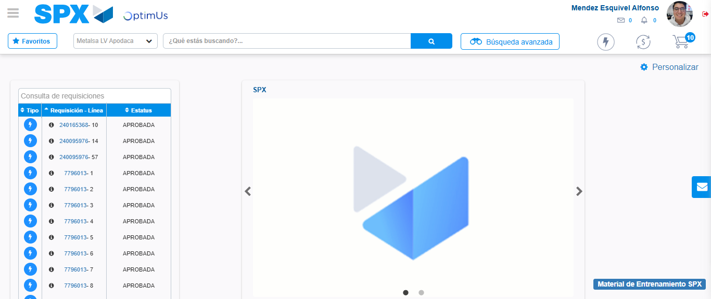Image file-name: QC_Testing-tc006_SPX_Dev5_Crear_Requisicion_Spot_Tipo_Cobro_Proyect_Urgent-1783362617907

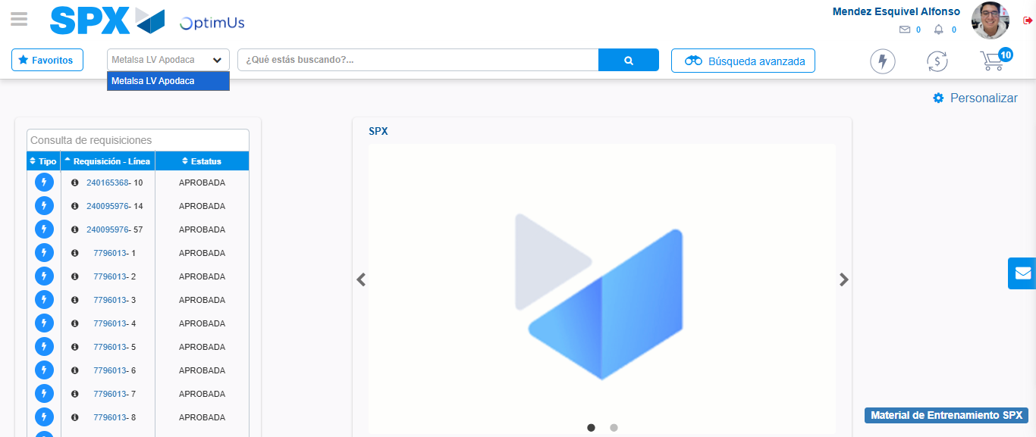Image file-name: QC_Testing-tc006_SPX_Dev5_Crear_Requisicion_Spot_Tipo_Cobro_Proyect_Urgent-1783362620407

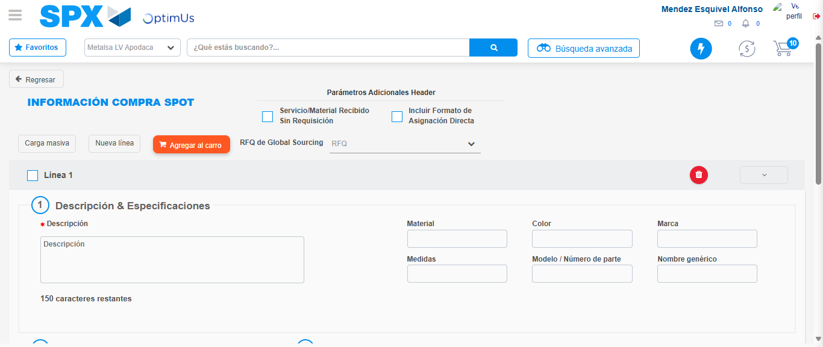Image file-name: QC_Testing-tc006_SPX_Dev5_Crear_Requisicion_Spot_Tipo_Cobro_Proyect_Urgent-1783362633517

Step 3 - Data Capture Spot Buy Requisition: Data captured correctly
Image file-name: QC_Testing-tc006_SPX_Dev5_Crear_Requisicion_Spot_Tipo_Cobro_Proyect_Urgent-1783362633743

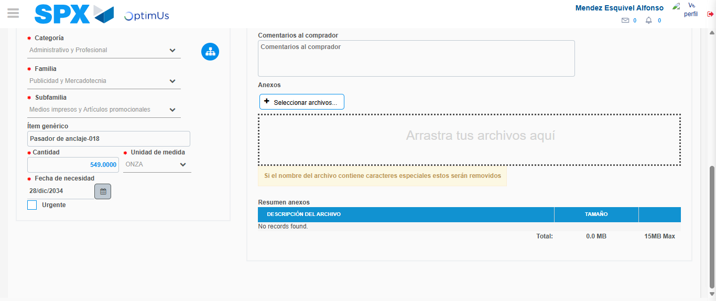Image file-name: QC_Testing-tc006_SPX_Dev5_Crear_Requisicion_Spot_Tipo_Cobro_Proyect_Urgent-1783362643573

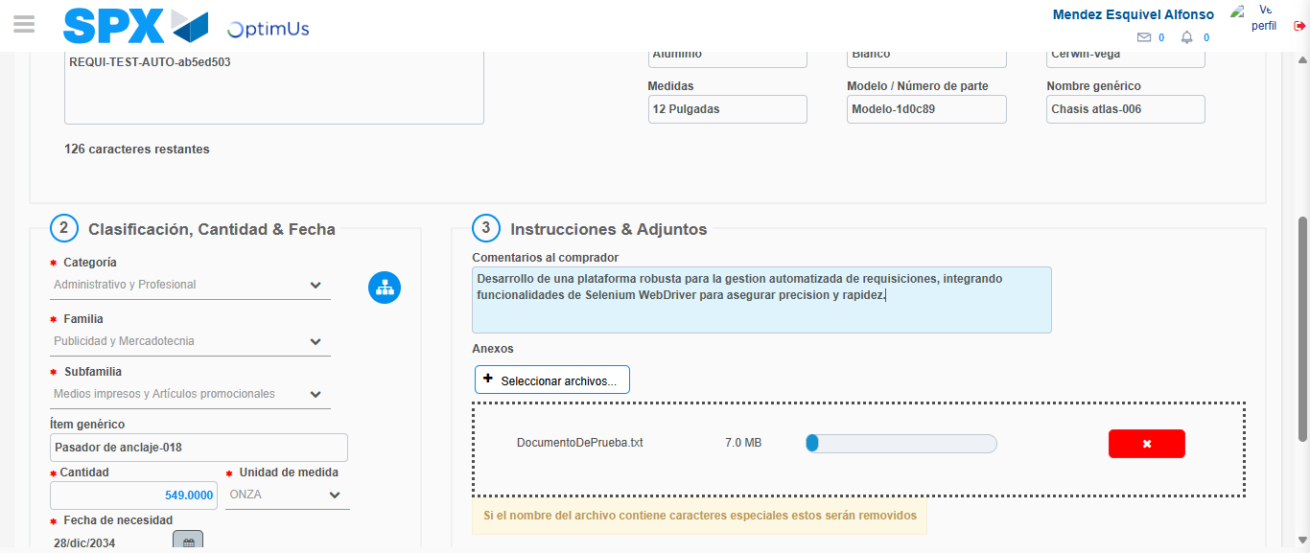Image file-name: QC_Testing-tc006_SPX_Dev5_Crear_Requisicion_Spot_Tipo_Cobro_Proyect_Urgent-1783362644352

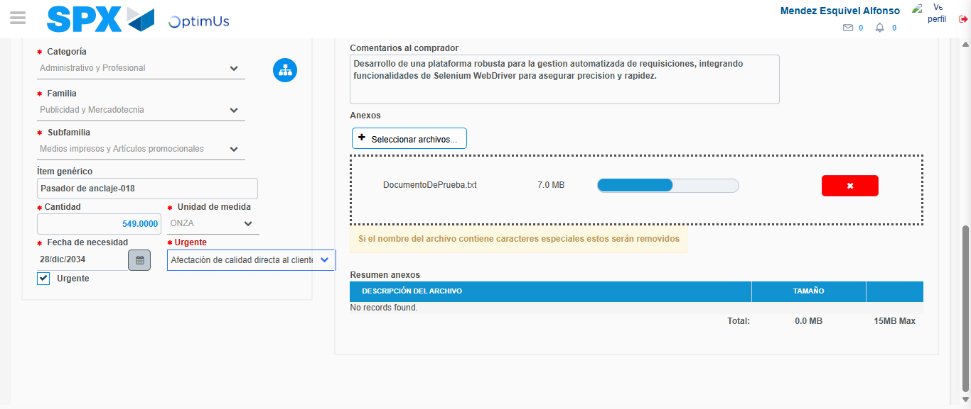Image file-name: QC_Testing-tc006_SPX_Dev5_Crear_Requisicion_Spot_Tipo_Cobro_Proyect_Urgent-1783362647436

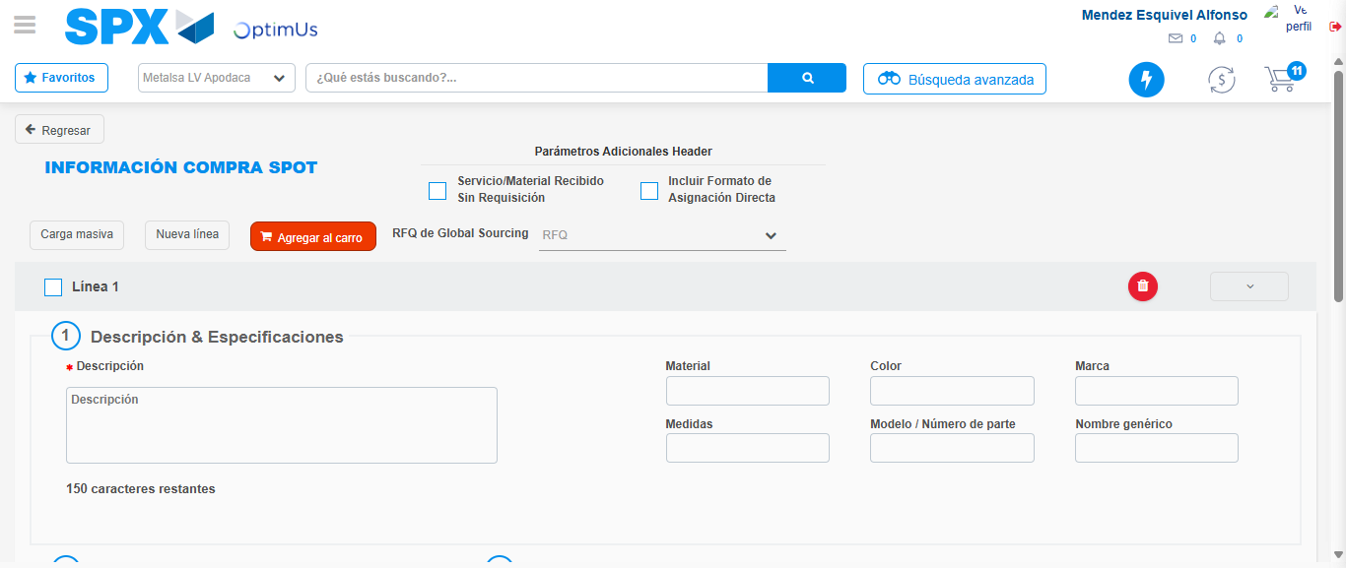Image file-name: QC_Testing-tc006_SPX_Dev5_Crear_Requisicion_Spot_Tipo_Cobro_Proyect_Urgent-1783362654376

Step 7 - Return to Main Page SPX : Return to Main Page SPX
Image file-name: QC_Testing-tc006_SPX_Dev5_Crear_Requisicion_Spot_Tipo_Cobro_Proyect_Urgent-1783362617907

Image file-name: QC_Testing-tc006_SPX_Dev5_Crear_Requisicion_Spot_Tipo_Cobro_Proyect_Urgent-1783362620407

Image file-name: QC_Testing-tc006_SPX_Dev5_Crear_Requisicion_Spot_Tipo_Cobro_Proyect_Urgent-1783362633517

Image file-name: QC_Testing-tc006_SPX_Dev5_Crear_Requisicion_Spot_Tipo_Cobro_Proyect_Urgent-1783362656579

Image file-name: QC_Testing-tc006_SPX_Dev5_Crear_Requisicion_Spot_Tipo_Cobro_Proyect_Urgent-1783362656745

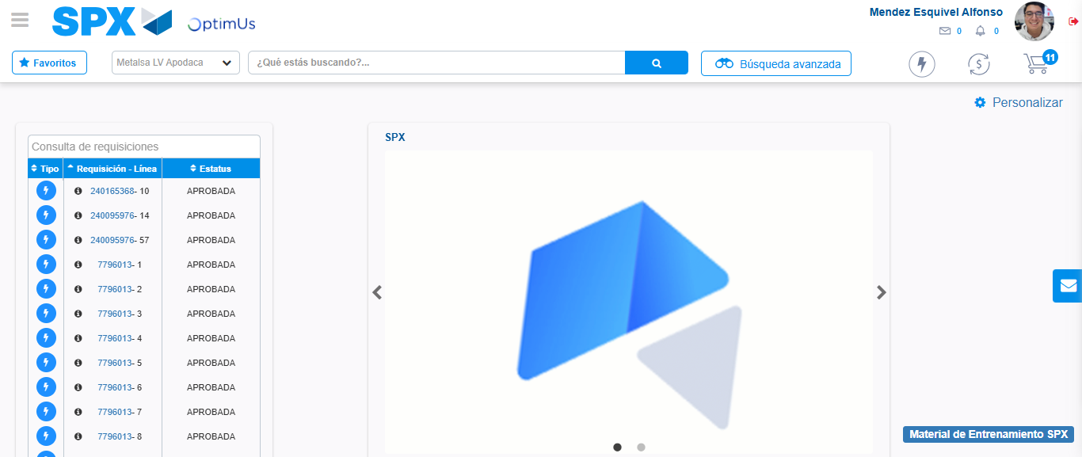Image file-name: QC_Testing-tc006_SPX_Dev5_Crear_Requisicion_Spot_Tipo_Cobro_Proyect_Urgent-1783362677873

Step 8 - Log Out : Log Out SPX
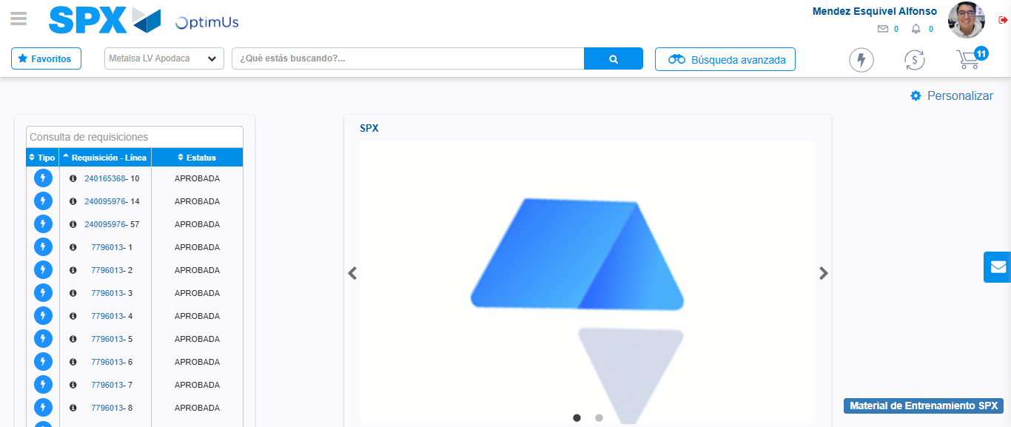Image file-name: QC_Testing-tc006_SPX_Dev5_Crear_Requisicion_Spot_Tipo_Cobro_Proyect_Urgent-1783362678075

